Documentation: Desktop UI codes

# Overview:

This documentation will provide an overview of how to approach the 2 codes (frontend code and backend code) in order to run the desktop toolkit application. The frontend code is named as “try.py”. The backend code is named as “try_backend.py”. Both the codes are written in python language.

# File locations of codes:

It is advisable to store the frontend code in a new/separate folder, dedicated to this toolkit related work. Let's refer to this folder as the main folder for this documentation.

In this main folder, make another folder named “backend”. Now, the backed code (try_backend.py) should be stored in this backend folder. Make sure that you update the path of this backend folder in the frontend code as shown on line no.11 in the figure below.

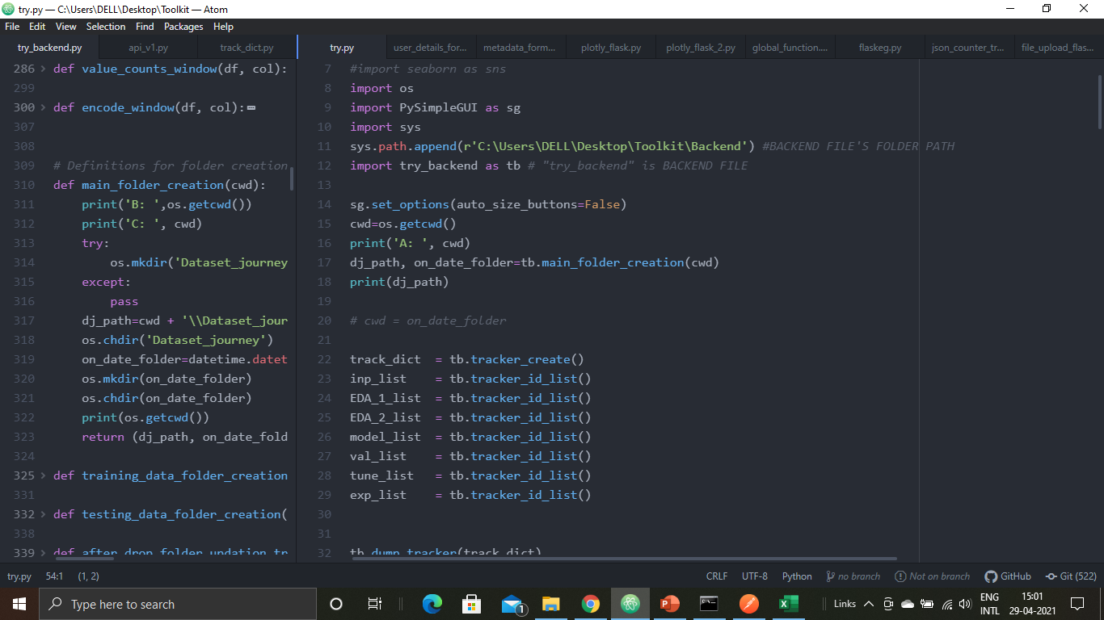

# Running codes:

To run the application, there are 2 ways:

1. Open command prompt (if windows OS), and run the frontend code. An example is shown below. After this, there will be a “Welcome” message, and the toolkit application window shall appear.

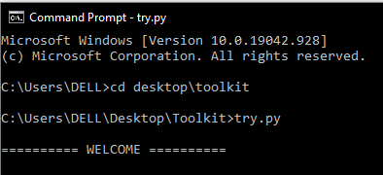

1. Otherwise, double click the frontend code (try.py), and the application shall open. Though doing this is not that heavily encouraged.

# Folder generations:

When the application is run for the first time, a “Dataset_journey” folder will be created in the main folder. This folder will hold all the project folders named after the date and time on which that project was created. As you go further into the application flow, the flow related contents will be accordingly updated in these project folders. An example is shown below.

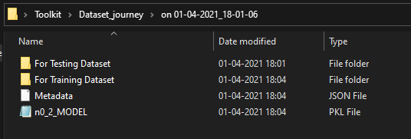

***** End of documentation *****